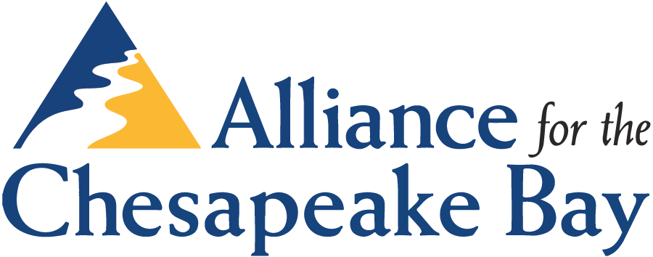

BOARD OF DIRECTORS MEETING MINUTES

October 21, 2016 — National Arboretum, Washington, DC

PURSUANT to notice, a meeting of the Board of Directors of the Alliance for the Chesapeake Bay was convened by Don Boucher, Chair, on Friday, October 21, 2016 at 10:15 AM at the National Arboretum, Washington, DC.

Members present: Don Boucher, Alex Beehler, Jim Elliott, Andrea Field, Bob Paul, Celeste Regan, Robin Clark ,Ginny Snead (via conference line),Dan Cornell (via conference line), Doug Lashley (via conference line), Steve Levitsky, Jack Detweiler, Brent Fewell, Chris Hamilton, Dennis Chestnut

Members not present: John Quinn, Bill Gill, Katie Maloney, Jennifer Troy, Paula Hamel, Rich Hart, Steve Pattison.

Alliance Staff present: Al Todd, Mary-Angela Hardwick, Jory Bender, Jaja Leroux, Erin O’Grady, Sarah Davidson, Lou Etgen, Marissa Spratley, Nissa Dean and Jessica Blackburn (via conference line).

Welcome and Introductions
The meeting was called to order at 10:15 AM. Don Boucher welcomed all board members and staff to the meeting and noted that we had enough members to make a quorum. Everyone present at the meeting introduced themselves. Al showed the Alliance promotional video and described its production and use. It will be available for viewing online when the newly reformatted website is launched on Nov.1.

Jim Elliott presented the July 2016 board meeting minutes which were reviewed and approved.

Jim provided 2017 meeting dates and locations as recommended by Al. Bob Paul reminded the Board that he offered to host one meeting at St. Mary’s College and suggested that July would be the best time as school was not in session. Al will revise the list and send it out to Members.

Business and Committee Reports

Development Report
Presented by Mary-Angela Hardwick. Taste of the Chesapeake 2016 raised a gross income of over $110,000 with a net of approx. $94,000. Taste sponsorships grew from 54 in 2015 to 64 in 2016. Although we did not receive support from some bigger sponsors, this growing list allows some hope of developing sponsors at higher levels in the future. Mary Angela gave a big shout out to Julie St. Marie who donated the entire desert table to support the Alliance. All of the caterers have expressed their support for our organization. Overall expenses were actually down this year and under $10,000 total which is amazing for an event of this scale. Recognition was given to Marissa for the great job for the

Silent Auction. The Taste is a great opportunity for development and communications outreach as well as a fundraising tool.

Jack Detweiler brought up that we need to further cultivate larger sponsors if we are going to increase donations in addition to so many smaller ones. Discussion of various improvements or comments on the event followed. Discussion of the value of the raffle and better ways to sell tickets, such as selling at the door as people come in, having multiple prizes or a larger prize, and engaging the caterers. The Board also discussed whether to move the location of the Taste for next year. The Arboretum has been proposed for several years. The idea of finding a location on the water was also suggested to make the Bay connection. It was suggested that a geographic study on participants and sponsors should be made to see where people are traveling from to attend and how sponsorship support is distributed.

In 2016, the focus has been increasing awareness of Alliance work and impact through regular communications with our members, Board and Honorary Directors, Sponsors, partners, Alliance staff and watershed residents. This was the last year of a two year direct mail campaign. Although the campaign raised awareness, it yielded no more than a dozen new members. Looking ahead to 2017, we have contracted with the River Network’s Mary Ellen Olcese, to work with the Board and Staff to create a more comprehensive Development and Fundraising Plan for the Alliance. An ad hoc committee with membership of the Development Committee will be formed to work with Mary Ellen to identify feasible fundraising strategies.

Marissa prepared a new Annual Report for 2015 as well as a new member brochure or “playbook” should be completed by end of 4th qtr 2016. The Annual Appeal will be mailed out before Thanksgiving. Fall. We will also be focusing on workplace giving campaigns.

A suggestion was made to use more metrics on the new website to show how specific programs are yielding results. Also better ways to distinguish the Alliance from the other Bay programs, especially CBF. Al said he had talking points and would share with Board members again.

Governance Report
Rich Hart was not present so, Al began the report by presenting recognition awards to the tenured Board Members who are going off the Board at the end of their terms. We recognized and thanked:
Alex Beehler, Don Boucher, Celeste Regan, John Quinn, and Chris Hamilton

Al also presented two special awards (wood cut maps of the Chesapeake Bay) to departing Board Members and Board Chairs, Don Boucher and Alex Beehler

Presentation of prospective Board Members was made by Jim Elliott. Each member was discussed and then a separate vote on acceptance was made. Five new Board Members for 2017 were approved unanimously: Joe Carnahan from VA, Kelly Gutshall from PA, Sally Horner from MD, Jan Jarrett from PA, and Tara Scully from DC. Thanks was given to the Governance Committee and all Board members who helped to conduct outreach to new board members. Al noted that in addition to new members we have approximately 10 prospective candidates on our future list who expressed interest in being considered in the future.

Board Members Jim Elliott, Paula Hamel, Richard Hart, Steve Pattison and Jennifer Troy were all re-elected for second term. Jim Elliott was elected as 2017 Secretary, Jack Detweiler was elected as 2017 Treasurer/Finance Committee Chair. In addition, although not elected, Rich Hart and Jennifer Troy agreed to continue as Governance and Development Committee Chairs respectively. Candidates are still be sought for Program Advisory Committee Chair as Bob Paul moves to Board Chair.

Al will talk to Rich Hart about notifying new Board Members and scheduling a Board Member Orientation.

Finance Report
Presented by Celeste Regan. The 2015 audit is complete and was once again a “clean audit”. The only note on the management letter was regarding a note was made by auditor to date invoices on day goods and services were received rather than date invoice is created. This change in procedure had already been made at the time the audit was complete. All acknowledged the great work of Board and Staff in reaching a milestone in 2015 of a positive unrestricted net asset balance.

Year to date income and expenses were presented next reflected finances as of 9/30/2016. In terms of income, overall Taste income was off a bit and donations are running behind projections. Donations YTD do not include the Annual mailing. While Grant Income is exceeding targets, unrestricted fund raising will likely end the year about $20-30,000 below projections. There will be fewer unrestricted funds for 2016.

Grants have continued growth and the Board appreciates the grant tracking spreadsheet and the hard work of staff to compete for and win new funds. Celeste asked about average $ per grant and whether it was growing. Al will work with Jaja to begin to track that metric.

Presentation of the 2017 Budget. The overall budget continues a trend in program success. With grants on hand and new anticipated funds, the Alliance projects its first budget of over $5 million. Projections of donations are more in line with projected success. In terms of unrestricted spending, the Innovation Fund will be continued to support employee led innovations that support advancement of strategic plan and a line item recognizes the intention to begin building an unrestricted reserve. As this is the first budget without a beginning deficit, Celeste pointed out that we are not yet at a point to better define this reserve but will need to monitor these trends in 2017 and beyond. .

In terms of major new items, a health benefits plan will be implemented in 2017. Alliance proposes to pay 50% of Alliance base plan for all employees. This benefit offering is the first for the Alliance and long overdue. The Board was fully supportive of continuing to monitor and to improve benefits for employees over time.

Upon motion made by Celeste Regan, seconded by Don Boucher and unanimously approved, it was RESOLVED that the 2017 operating budget is approved.

Upon motion made by Celeste Regan, seconded by Don Boucher and unanimously approved, it was RESOLVED that the company of Anderson, Davis & Associates would perform the 2016 audit.

Expanding Diversity in Organizations and Stewardship Action
This topic was presented by Board Member Dennis Chestnut and Alliance Staff Sarah Davidson. Working with partners and communities is central to the identity of the Alliance. It will take a wide-spread social movement to restore and sustain the Chesapeake Watershed. The process must be a systemic cultural shift, embedded in the way the organization is governed. All felt that this is an area that the organization can continue to improve on. Focus should be on both recruiting for vacant positions as well as better integration of initiatives for diversity into Alliance program delivery.

RECOMMENDATIONS TO THE BOARD
A comprehensive set of recommendations were provided to the Board of ways to demonstrate support for diversity and inclusion in Alliance work and programs. In particular:

  - Make an intentional and meaningful commitment at the board and staff levels to prioritize a culture of diversity and inclusion
  - Act with deliberate focus and intention toward diversity
  - Develop multi-cultural competency, sensitivity, and empathy among board and staff members

The Board expressed its appreciation and support and then discussed a list of concrete actions in order of importance to start the process. It was suggested that the Staff work with Dennis to develop a statement of diversity commitment and an initial action plan to be presented as a Board Resolution at the January 2017 Meeting.

Director’s Report
Time ran out for providing the full Director’s Report. Al will post his presentation to the Board Resource page and will provide a more complete overview of Strategic Plan status at the January Meeting.

Executive Session began at 2:15.

Next Board Meeting will be on January 27.

Meeting adjourned at 2:45 pm

