Facilities

Dining
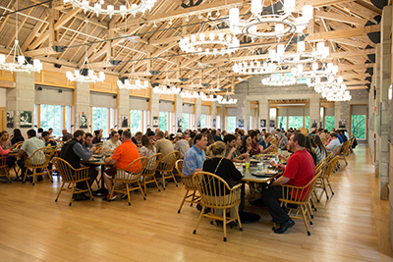
Dining services are available on the second floor of the Commons building. A wide variety of menu items are offered. Food choices support many dietary needs. Food and beverage services and hours may vary on weekends, based upon occupancy.

Breakfast: 6:30- 9:00 a.m.
Hot food until 8:30 a.m.
Lunch: 11:30- 1:30 p.m.
Hot food until 1:00 p.m.
Dinner: 5:30-7:30 p.m.
Hot food until 7:30 p.m.

Lodging
NCTC can accommodate 226 guests throughout four lodge buildings situated within a sycamore grove between the Commons Dining/Physical Training buildings and Instructional Buildings. Several rooms are equipped with ADA support or double occupancy.
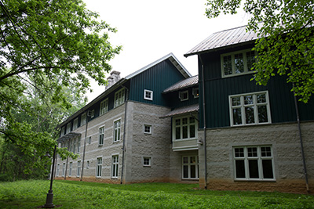

Lodging details include:
- Reservations/Confirmation Policy
- Lodging Rates
- Facility Sustainability Fee
- Check-in/Check-out
- Meal Plans
- Lodge Room Amenities

Lounge/Roosevelt Room/Social Center
Social Center is located in the Commons building’s Roosevelt Room and Lounge. Beer, wine, and soft drinks are available. Only alcohol purchased at the NCTC lounge is permitted in the Commons building and adjacent patios.
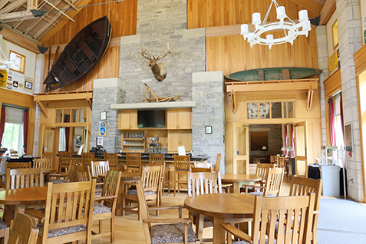
Hours: Sunday - Thursday 5:30 - 11:00 p.m. and on occupied weekends. Hours are subject to change during low-attendance periods.
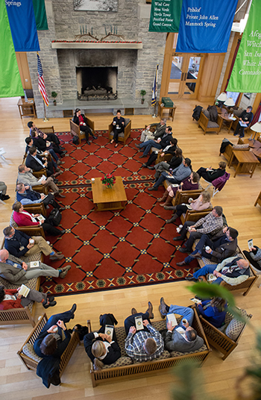

Complete facilities information can be found here.

