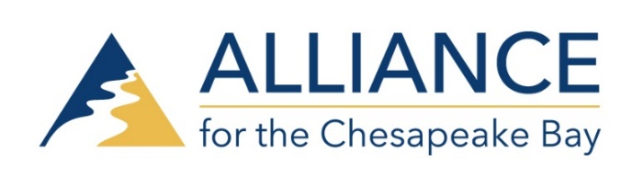
To: Alliance for the Chesapeake Bay Board
From: Mary-Angela Hardwick, Director of Development and Communications
Date: November 2018 Board Meeting
RE: Development and Communications Update
Taste 2018 Report:
Our Taste 2018 was our most successful Taste ever! Our net income was $111,327.00 – our highest Taste net income ever! (Our net income in 2017 was $105,675, in 2016 it was $90,986). Our gala was attended by over 400 guests. Through generous in-kind donations and the generosity of our caterer Palate Pleasers our Food & Drink expenses were about 50% less than 2017. We had 60 Taste sponsors and raised a record number of Sponsorship dollars at $110,500. We have been following up with our Taste guests and sponsors to expand our engagement and partnerships opportunities through the end of the year with letters of thanks and updates on our work across the Chesapeake. We will continue to advance our outreach to these supporters in 2019.
Communication and Development Update:
A full report on our Fund Development in 2018 will be provided at our January 2019 meeting.
Throughout this year, we have focused on the goals set in our 2018 Fund Development Plan. Staff have provided expanded reports on their work and impact throughout the year which we have shared through regular communications with our donors, Board and Honorary Directors, Sponsors, and partners.
Highlights for Communication and Development include
- Redesign of our Alliance logo
- Unique We (heart) the Chesapeake Campaign
- Redesign of our Alliance brochure
- We have doubled our supporter outreach to over 16,000 supporters ( our supporters in 2017 numbered approximately 8,000)
- Review of Alliance SalesForce database to identify strongest supporters and Major Donors and focus on personal outreach throughout 2018.
Our regular and ongoing engagement and fund development activities include:
- Monthly newsletter
- VIP engagement including personal visits, a unique gathering in DC this spring with our MD and DC Honorary Directors and Board members.
- Our MidYear Appeal, lapsed donor, and membership renewal mailings
- Daily social media outreach
- Press releases, program and grant writing support
- Unique special events through our state offices, including our newest event in Richmond Cheers to the Chesapeake, in addition to our annual Taste of the Chesapeake

4Q 2018
As we enter into 4Q 2018, we are preparing our Annual Appeal Campaign and our associated communication plan. Our fund goal for this year’s Annual Appeal campaign is $30K. Our Annual Appeal Campaign includes regional- focused letters mailed to our unique audiences in PA, MD, DC, and VA. The Annual Appeal will be mailed on November 9th so that our supporters will receive our Appeal by November 15th at the start of the official holiday season. We will follow up with a strong social media campaign including Giving Tuesday on November 27th. In Pennsylvania we will participate again this year in the Great Extraordinary Give on Friday, November 16th in Lancaster County. We are also busy finalizing our 2018 Annual Report, continuing to update and improve our website, and supporting preparations for the Chesapeake Watershed Forum and participation in the Wild and Scenic Film Festival in January 2019 by all 3 State Offices.
Board Giving 2018 Update: We hope to have 100% Board participation as we did last year! It is very important when writing grants to be able to state that 100% of the Alliance Board supports the Alliance Fund Development. To date we have pledges and donations totaling $10,251. For those who have not fulfilled their pledge yet, please mail your donation or go online at allianceforthebay.org to before December 31st. Please also consider if your employer offers a matching gift.

Looking Ahead to 2019:
To begin the process of drafting our 2019 Fund Development Plan for the Alliance, the Board Development Committee will meet in early December through early January and work with Alliance staff to set priorities and goals for next year. The Alliance 2019 Fund Development Plan, which will be presented for Board review and approval at the January 2019 Board meeting.

